REBASEING

git-rebase - Reapply commits on top of another base tip

A---B---C topic

/

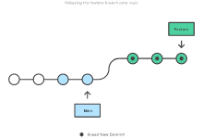 D---E---F---G master

From this point, the result of either of the following commands:

>git rebase master

>git rebase master topic

would be:

A'--B'--C' topic

/

D---E---F---G master

Files

If the upstream branch already contains a change you have made (e.g., because you mailed a patch which was applied upstream), then that commit will be skipped and warnings will be issued (if the merge backend is used). For example, running git rebase master on the following history (in which A' and A introduce the same set of changes, but have different committer information):

A---B---C topic

/

D---E---A'---F master

will result in:

B'---C' topic

/

D---E---A'---F master

MERGING

git-merge - Join two or more development histories together

A---B---C topic

/

D---E---F---G master

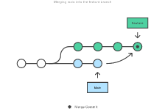Then "git merge topic" will replay the changes made on the topic branch since it diverged from master (i.e., E) until its current commit (C) on top of master and record the result in a new commit along with the names of the two parent commits and a log message from the user describing the changes.

A---B---C topic

/ \

D---E---F---G---H master

References:

1. <https://git-scm.com/book/en/v2/Git-Branching-Rebasing>
2. <https://git-scm.com/docs/git-rebase>
3. <https://git-scm.com/docs/git-merge>
4. <https://www.atlassian.com/git/tutorials/merging-vs-rebasing>
5. <https://www.atlassian.com/git/tutorials/rewriting-history/git-rebase#:~:text=Rebase%20is%20one%20of%20two,has%20powerful%20history%20rewriting%20features>
6. <https://stackoverflow.com/questions/16666089/whats-the-difference-between-git-merge-and-git-rebase/16666418#16666418>